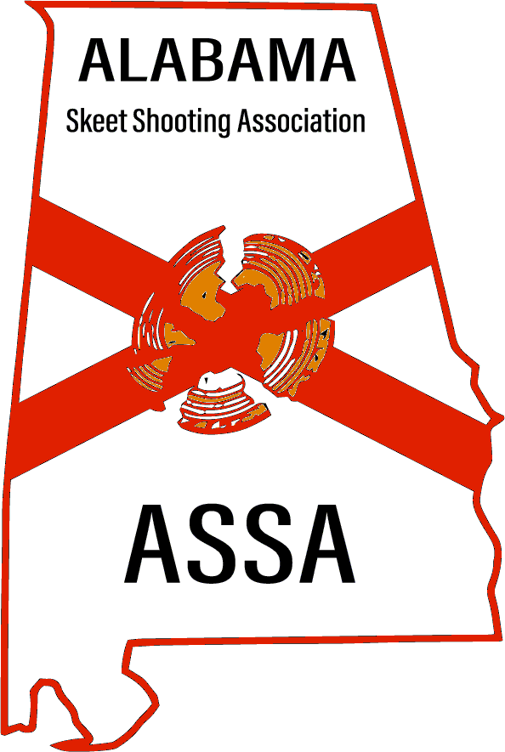  Get Ready…….SAVE THE DATE….  September 6-8 2024, the Army Aviation Shotgun Club at Ft Novosel in South Alabama will be hosting the 2024 State Skeet Shooting Championship. This event is opened ONLY to Alabama residents, High School, and Collegiate shooters attending school in the state, and Military service members stationed in the state of Alabama.  Visit: ArmyAviationshotgunclub.com for location, access requirements, lodging, campgrounds, and other important information. MORE INFO TO FOLLOW……  Enter as an individual, create a 2-person team, 5-person team, school team, or club team. Registration will open 1 April 24. Deadline to enter is 15 August 24. All shooters who enter by 1 July 24 will be entered for the chance to win a free entry into the event (5-Guns, approximately a $300 value) sponsored by the Alabama Skeet Shooting Association. This is a 5-gun event, Doubles, 12 ga, 20 ga, 28 ga and .410 bore.  Email: AlskeetVP@gmail.com to register, or visit: www.alskeet.org | Alabama Skeet Championship  Sept 6-8, 2024  Alabama Skeet Championship  Sept 6-8, 2024  Alabama Skeet Championship  Sept 6-8, 2024  Alabama Skeet Championship  Sept 6-8, 2024  Alabama Skeet Championship  Sept 6-8, 2024  Alabama Skeet Championship  Sept 6-8, 2024  Alabama Skeet Championship  Sept 6-8, 2024  Alabama Skeet Championship  Sept 6-8, 2024  Alabama Skeet Championship  Sept 6-8, 2024  Alabama Skeet Championship  Sept 6-8, 2024  Alabama Skeet Championship  Sept 6-8, 2024  Alabama Skeet Championship  Sept 6-8, 2024  Alabama Skeet Championship  Sept 6-8, 2024
Alabama Skeet Shooting Association
2024 Shoot Calendar
DATE | EVENT | LOCATION
Feb 24 | North Winds Open | Cullman County
Mar 8-9 | March Winds Open – 3 x 100 | Headland Skeet & Gun
Mar 8-10 | March Madness Open | Redstone MWR
Mar 15-17 | Ides Of March Open | MARS
Mar 16 | Bill Perry Memorial Open | Red Eagle Skeet & Trap
Mar 16 | Wicksburg – 12 Ga JR/Sub JR Only | Ft. Novosel
Mar 22-24 | Apache Open – 5 Guns | Ft. Novosel
Apr 5-7 | April Fools Open | Redstone MWR
Apr 6 | Emannuel Christian – 12 Ga JR/Sub JR Only | Ft. Novosel
Apr 8-10 | March Madness Open 4 x 100 | Redstone Arsenal MWR
Apr 13 | Miner Cliett Open | Red Eagle Skeet & Trap
Apr 19-21 | Warrior Open – 5 Guns | Ft. Novosel
Apr 19-21 | Tax Man Cometh Open | MARS
Apr 27 | Spring Warm-up | Cullman County
May 4 | Ironman Memorial Open – 2 x 100 | Southern Skeet & Trap
May 17-19 | Danny Pugh Open – 5 Guns | Ft. Novosel
May 10-11 | Little Money Open – 3 x 100 | Headland Skeet & Gun
May 26 | David Barron Memorial | Red Eagle Skeet & Trap
May 31 – Jun 2 | L.A. Open – 5 Gun | Ft. Novosel
Jun 14-16 | June Bug Open | Redstone MWR
Jun 21-23 | US Open – 5 Guns (Alabama Host Site) | Ft. Novosel
Jun 28-30 | Summer Days | MARS
Jul 13 | Dog Days Open – 2 x 100 Shooters Choice | Redstone MWR
Aug 9-11 | Zone 4 iShoot – 5 Guns (Alabama Host Site) | Ft. Novosel
Sep 6-8 | **Alabama State Championship – Closed Event | Ft. Novosel (Host Club)
Sep 14 | Cahaba Classic – 2 x 100 Shooter’s Choice | Southern Skeet & Trap
Sep 20-21 | Headland Harvest Open | Headland Skeet & Gun
Sep 27-Oct 5 | NSSA World Shoot | NSC, San Antonio TX
Oct 5 | Pat Patterson Open | Red Eagle Skeet & Trap
Oct 12 | Coffee County/E’prise – 12 Gauge JR/Sub JR Only | Ft. Novosel
Oct 18-19 | Peanut Pickin’ Open 3 x 100 | Headland Skeet & Gun
Oct 18-20 | Falling Leaves Open | MARS
Nov 1-3 | Redneck Open – 5 Guns | Ft. Novosel
Nov 9 | Veterans Day Shoot – 2 x 100 Shooters Choice | Redstone MWR
Nov 16 | Southern Open – 2 x 100 Shooter’s Choice | Southern Skeet & Trap
Dec 7 | ECS Winter Warrior Shoot | Headland Skeet & Gun

