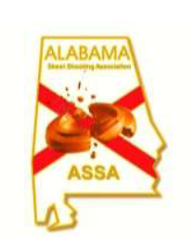

**Registration for the**

**ALABAMA STATE SKEET CHAMPIONSHIP**

**Held on Redstone Arsenal, hosted by the MARS & MWR Shotgun Clubs**

**Redstone Arsenal, AL 35808**

**Sept. 5-7, 2025**

**SAVE THE DATE**

**DETAILS COMING SOON**